I2C Between 2 Arduino’s

For our first experiment we will hook two Arduinos together and exchange data between them. One Arduino will be the master, the other will be the slave.

I’m using two Arduino Unos, but you can substitute other Arduino’s if you don’t have two Unos. Use the previous chart for the connections.

Hooking up 2 Arduino’s

Here is how I connected my two Arduino Unos together:

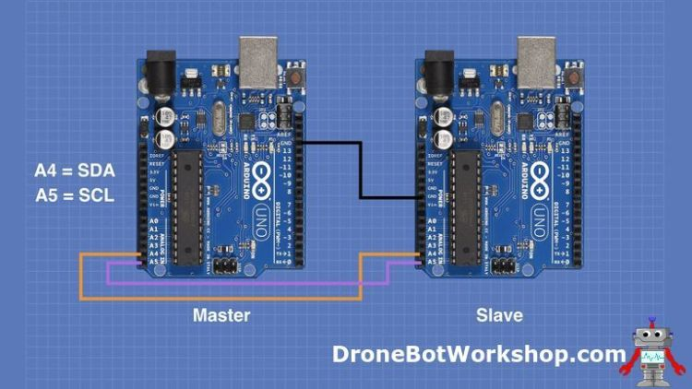

It is quite a simple hookup, essentially you just tie the ground and the two I2C pins together.

One thing to be aware of is that my diagram does not show the use of pull-up resistors, I found that everything seemed to work correctly without them.  However, you might want to include them, especially if you experience errors or intermittent operation.

To hook up some pull-up resistors attach a couple of 10k resistors to the SDA and SCL lines. Attach the other end to the 5-volt output on one of the Arduino’s.